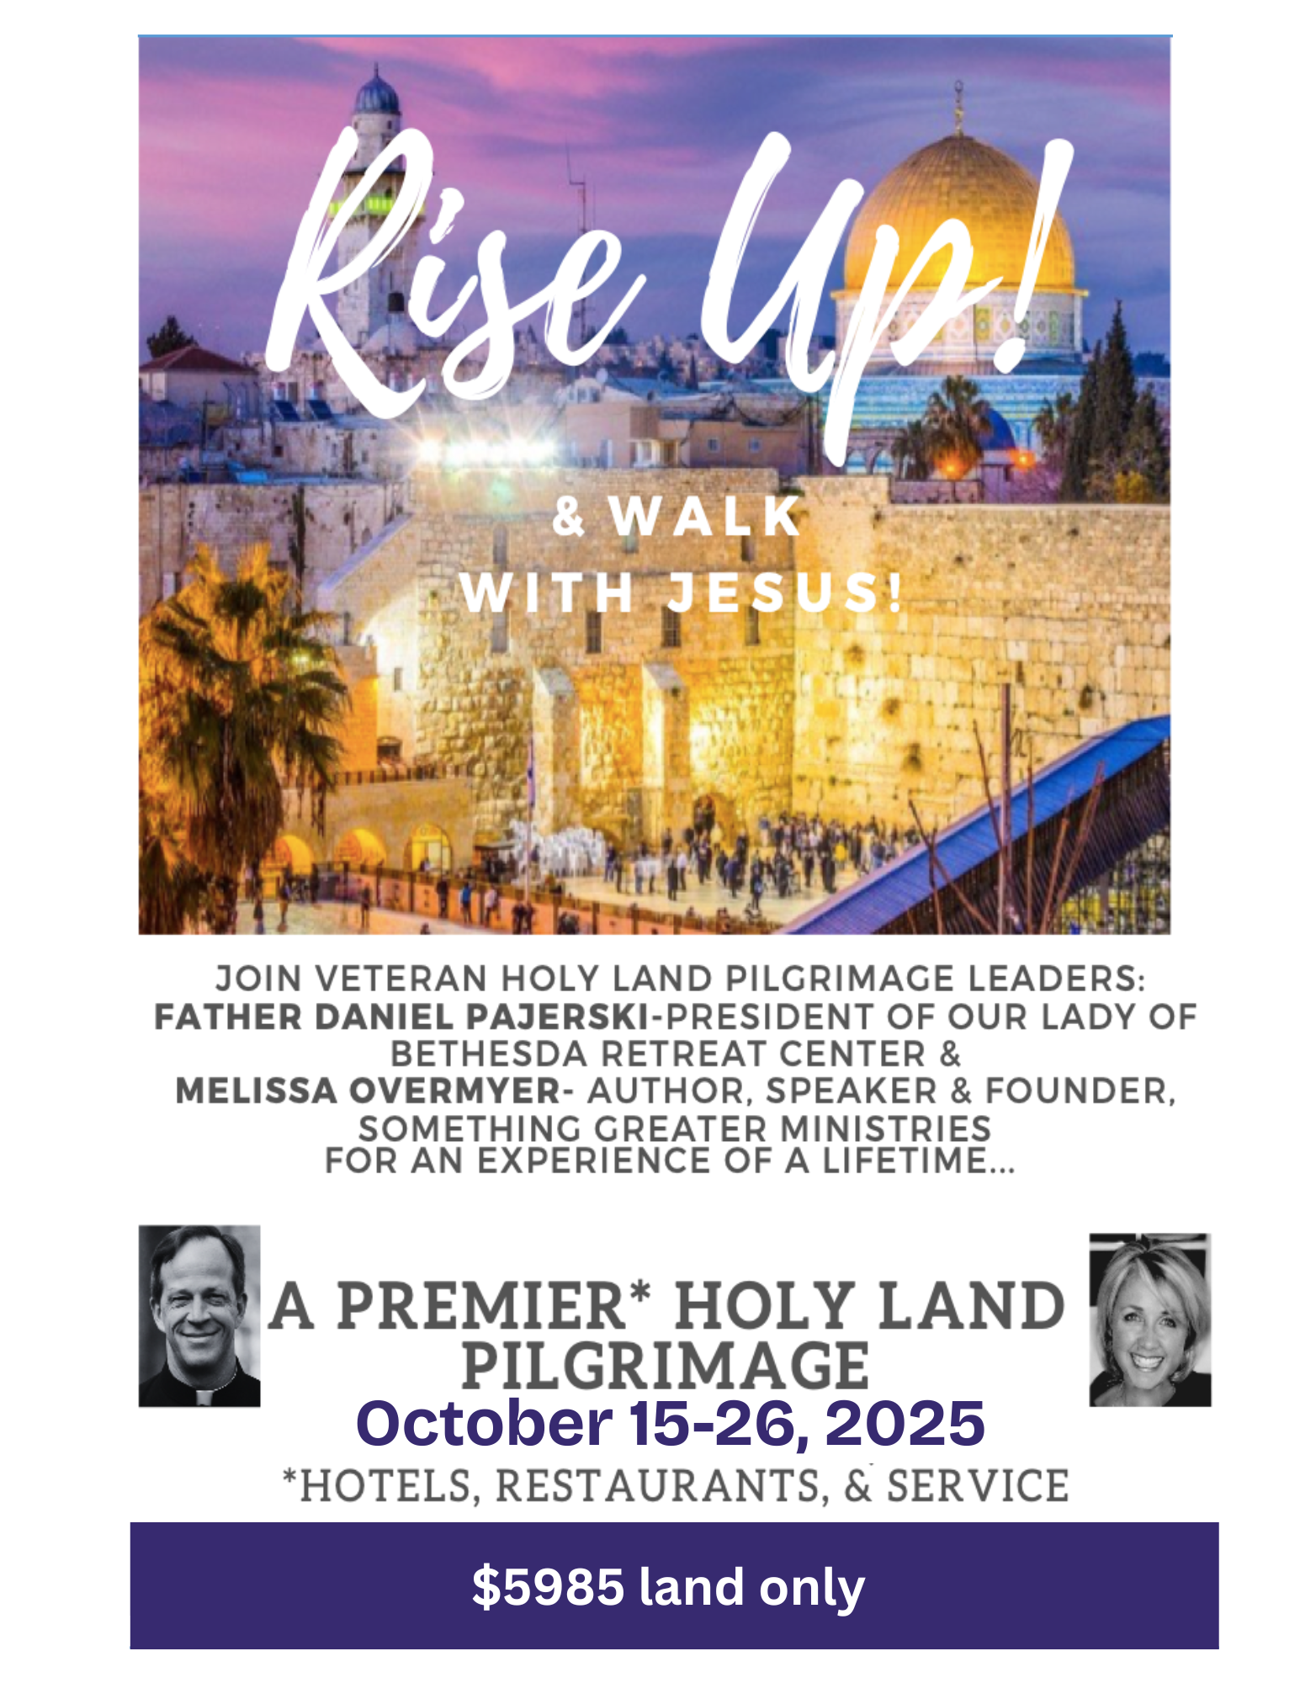

**Holy Land Pilgrimage** **Itinerary**

**October 15-26, 2025**

**Wednesday Oct 15 2025**: Depart from USA to Tel Aviv, Israel

**Day 1, Thu, Oct 16 - SAMARIA & NORTHERN ISRAEL**

Upon arrival at Ben Gurion airport in Tel Aviv, we will be met by our tour guide and bus driver. **Stop 1:** **Joppa-** the ancient Port City of Jonah and the Whale and Peter’s vision. Mass at St. Peter’s Church. **Stop 2:** Dinner and overnight at The Magdala Hotel.

**Day 2, Fri, Oct 17 - GALILEE**

**Stop 1:** **Cana:** where Jesus performed His first miracle- water into wine! Renew marriage vows in the Church of Marriage. **Stop 2**: **Nazareth:** the **Basilica of the Annunciation,** built over where the Angel Gabriel appeared to Mary, **underground to archaeological discoveries**. **St. Joseph’s Church**, **Mary’s Well**, and **synagogue** where Christ preached. **Stop 3: The Church of the Transfiguration,** sitting atop Mt. Tabor. **Stop 4:** Dinner and overnight The Magdala Hotel

**Day 3, Sat, Oct 18 - AROUND the SEA of GALILEE**

**Stop 1- Boat ride on the Sea of Galilee**, Museum of the Boat ancient boat dating back over 2000 years. **Stop 2:** **Capernaum:** **St. Peter’s home**- Jesus’ home base for public ministry and the **synagogue** where Jesus proclaimed the Bread of Life Discourse. **Stop 3:** **Mt. of Beatitudes**, site of the Sermon on the Mount. **Stop 4:** **Church of Tabgha**--miracle of the multiplication of the fish and loaves, **Stop 5: The Church of Primacy**, where our Lord entrusted the care of the Church to St. Peter as the first Pope**. Stop 6:** Dinner and overnight at The Magdala Hotel.

**Day 4, Sun, Oct 19 - The GOLAN HEIGHTS**

**Stop 1:** **Caesarea Philippi** and the **archaeological site of Pan**. St Peter professed his belief in Jesus as the Son of God and then view spectacular waterfalls. **Stop 2: Tel Dan**, the site of Abraham’s Gate. **Stop 3:** **Kursi,** Where Jesus cast out the Legion of demons into a herd of swine. **Stop 4:** Lunch and archeological site of **Magdala** and the beautiful Duc in Altum Church. **Stop 5:** Dinner and overnight at The Magdala Hotel.

**\*Day 5, Mon, Oct 20** – **Archaeological Dig Day-Bethsaida**

PREMIER DAY! Melissa Overmyer will lead the group in an on-site visit and participation in the archaeological dig at Bethsaida, the town where St Peter and St Andrew grew up.

Dinner and overnight at The Magdala Hotel.

**Day 6, Tue, Oct 21**—**ALONG THE MEDITERRANEAN to JERUSALEM!**

**Stop 1:** **Mt Carmel,** and visit to the convent of Stella Maris and the Grotto of the Prophet Elijah. **Stop 2: Caesarea Maritime.** There you will visit one of the best-preserved hippodromes, amphitheater, and aqueducts in the world. **Stop 3:** **JERUSALEM!** Dinner and overnight at the Notre Dame of Jerusalem Center.

**Night walk in the Old city.**

**Day 7, Wed, Oct 22 - EIN KAREM and BETHLEHEM**

**Stop 1: Ein Karem and** the **Church of the Visitation**, where the Virgin Mary met Elizabeth. **Stop 2: Church of St. John the Baptist.** **Stop 3:** **Bethlehem-the Basilica of the Nativity**, the **Chapel of St. Jerome**, **the Milk Grotto**, LUNCH in Bethlehem and SHOPPING! **Stop 4:** **Shepherds Fields**. **Stop 5:** Dinner and overnight at the Notre Dame of Jerusalem Center.

**Day 8, Thu, Oct 24** - **JERUSALEM!**

**Stop 1:** Dawn Mass (to be confirmed) at the **Holy Sepulcher**. **Stop 2:** After Mass, breakfast at the hotel. **Stop 3:** Walking tour of the **Old City of Jerusalem. Stop 4:** **Temple Mount Area**, the Western Wall, the Dome of the Rock, Al Aqsa Mosque, **Stop 5:** **St. Anne's Church,** and Bethesda’s Pool. **Stop 6: Lunch, Stop 7:** **Via Dolorosa :**the Flagellation Church, Ecce Homo, arriving at the Holy Sepulcher **Stop 9: Archaeological Tour of Tunnels under Western Wall followed by a visit to the Israel Museum Stop 10:** Dinner and overnight at the Notre Dame of Jerusalem Center.

**Day 9, Fri, Oct 23 - JORDAN RIVER, JERICHO & the DEAD SEA**

**Stop 1:** Bethany and the Tomb of Lazarus **Stop 2:** Renew Baptismal vows in the Jordan River where John Baptized Jesus**. Stop 2: Jericho,** the oldest and most continuously inhabited city in the world, cable car up to **the Mt of Temptations. Stop 3: Qumran.** Essene Monastery, the Dead Sea scrolls. **Stop 4:** LUNCH, MUD BATHS and SWIMMING in **the Dead Sea** at the Luxurious Isrotel Dead Sea Hotel. **Stop 5:** Dinner and overnight at the Notre Dame of Jerusalem Center.

**Day 10, Sat, Oct 25** –**MT. of OLIVES**

**Stop 1: On the Mt. of Olives**, Ascension Chapel, commemorating Our Lord’s Ascension into Heaven. **Stop 2:** Pater Noster- the sight of **the Our Father**. **Stop 3:** Church of Dominus Flevit, where our **Lord wept** over the city of Jerusalem. **Stop 4:** **Garden and Church of Gethsemane**, the site of the Agony in the Garden. **Stop 5:** Mt. of Zion-the Church St. Peter in Gallicantu-where **St. Peter denied Jesus** three times. **Stop 6:** **The Cenacle,** the site of the **Last Supper Stop 7:** **Dormition Abbey**- Virgin Mary’s passing into eternal life. **Stop 8:** Dinner and overnight at the Notre Dame of Jerusalem Center.

**Day 11, Sun, Oct 26 - EMMAUS & BEYOND…**

**Stop 1:** the Benedictine Church of Emmaus-his disciples recognized him in the breaking of the Bread. **Stop 2:** Onwards- those flying home will be taken to Ben Gurion airport for their flight back to the US.

**Price per person in a Double room (NOT including airfare): $5985/person**

**Price per person in Single Room (NOT including airfare): $7325/person**

**The above rates include:**

-10 nights’ Premier accommodations & all meals.

-Daily Mass at Holy Sites, Theological talks, Archeological exploration, and English-speaking tour guides

-Deluxe transportation

-All entrance fees

-Porterage fees at all hotels

-Audio guiding system

-Daily lunches at local restaurants

-Tips for guide, bus driver, hotels and restaurants

-Farewell dinner at the spectacular rooftop Wine & Cheese Restaurant in Jerusalem

*Premier dinning at Israel’s finest: Magdalena, Yudale and Chakra restaurants –dates to be determined closer to trip.

**The above rates do not include:**

-Any personal expenses such as telephone calls, beverages, laundry, and medical insurance.

-Anything not mentioned above.

**CHILDREN UNDER 18:** For a minor under the age of 18 to travel out of the United States without both parents or legal guardians, a notarized affidavit from the non-travelling parent(s) or guardian(s) must be obtained and presented upon departure and return to the United States.

**STATE DEPARTMENT & OTHER AGENCIES:** From time to time the State Department (www.state.gov) and the Center for Disease Control (www.cdc.gov) and other government agencies and departments issue travel advisories or warnings for one or more of the destinations that you may be visiting on tour. We encourage you to contact these agencies directly to obtain the most current information. CTS cannot change the cancellation terms or conditions based on the issuance of any such warning or advisory or the occurrence of any terror, health or other incident in one or more of the places this tour is scheduled to visit. All cancellation penalties remain in full force and effect.

**UNUSED SERVICES:** There is no right to a refund for any unused services.

**PARTIAL PACKAGES NOT AVAILABLE:** Tour Packages are offered only as described in this brochure, at the stated price. For liability reasons, it is not possible to purchase a partial package.

**DEPOSIT AND CANCELLATION POLICY:**

A deposit of $500/per person is required by June 1, 2025

Deposit is fully refundable if you cancel by June 30, 2025

**Full payment** should be received by September 1, 2025

Checks should be made payable to Our Lady of Bethesda Retreat Center and mailed to Fr Daniel Pajerski, at:

Our Lady of Bethesda Retreat Center

7007 Bradley Blvd

Bethesda, MD 20817

Cancellation:

**If an individual cancels** between July 1 and August 31, a cancellation fee of $500 will be applied.

**If an individual cancels** after September 1, full cancellation fees will be applied.

**TRAVEL PROTECTION:** Via Emmaus highly suggests the purchase of travel protection, to help protect travelers’ investment in the trip, and to help provide certain medical coverage while they are outside the USA. Plans help provide coverage for unexpected circumstances and help protect your trip and your investment.

**We recommend contacting an insurance agency in the United States.**

**PASSPORT:** A valid U.S. Passport is required of all passengers. Please apply for your passport immediately as passports may take a long time to process. Make sure to have it in your possession at all times while on tour. It must be valid for 6 months following the return date of the trip or boarding or entry into the destination may be denied.

For further questions please contact Via Emmaus Tours Co. Ltd.

Website : [www.viaemmaustours.com](http://www.viaemmaustours.com)

**RELEASE:** Via Emmaus Tours Co. Ltd., its employees, shareholders, officers and directors (collectively Via Emmaus) does not own or operate any entity which is or does provide goods or services for your trip, including, for example, lodging facilities, transportation companies, including, without limitation, various entities which may utilize Via Emmaus name, guides, sightseeing companies, entertainment, food or drink service providers, equipment suppliers, etc. As a result, Via Emmaus is not responsible for any negligent or willful act or failure to act of any person or entity. In addition, Via Emmaus is not responsible for any negligent or willful act or failure to act of any other person or entity it does not own or control. Without limitations Via Emmaus is not liable for any direct, indirect, consequential, or incidental damage, injury, death, loss, accident, delay, inconvenience or irregularity of any kind which may be occasioned by reason of any act or omission beyond its control, including, without limitation any willful or negligent act, failure to act, breach of contract or violation of local law or regulation of any third party such as a cruise line, airline, train, hotel, bus,taxi, van, or guide, whether or not it uses the Via Emmaus name, financial default or insolvency of any supplier which is to or does supply any goods or services for this trip. Similarly, Via Emmaus is not responsible for any loss, injury, death or inconvenience due to delay or changes in schedule, overbooking of accommodation, default of any third party, attacks or bites by animals, insects or pests, injury or death while on activities sponsored by lodging facilities or by other third parties, sickness, the lack of appropriate medical care, evacuation to same, if necessary, weather, strikes, acts of God or government, acts of terrorism, or the threat thereof, force majeure, war, quarantine, epidemics, or the

threat thereof, criminal activity, or any other cause beyond its control.

Should Fr. Daniel Pajerski or Melissa Overmyer be unable to participate in this event, reasonable commercial efforts will be made to secure a substitute. Regardless of the participation of Fr Daniel Pajerski or Melissa Overmyer the tour will proceed as scheduled on the dates listed. By signing this form to participate on this trip you agree that the terms of the cancellation penalty will be binding upon you regardless of whether Fr. Daniel or Melissa is able to participate. Via Emmaus is not responsible for any loss incurred by traveler, including lost days of the scheduled cruise/tour, due to a cancelled flight or other means and modes of transportation.

**TERMS AND CONDITIONS**

**ITINERARY:** The Itinerary as presented in this brochure is tentative and represents what we are planning for you, however, it is subject to confirmations from many organizations. Because of changes in local schedules, we may need to alter specified events, dates and/or venues to better fit the overall plan. The right is reserved to alter or cancel the itinerary, at Via Emmaus sole discretion, as it may deem necessary or advisable.

**ROOMS:** Tour prices are per person according to a room type: a “Single” room is one person in a room and a “Double” is two persons in one room. Triples are one double bed with two persons sharing the bed and one single bed. Triples are not always available and are discouraged because of cramped quarters.

**LUGGAGE:** Baggage is at owner’s risk throughout the tour.

**HEALTH REQUIREMENTS:** Travelers must be medically and physically fit for this tour. This tour requires significant walking, as motor coaches are not permitted to pick up and drop off in front of major attractions. The tour is not wheelchair accessible and is not suitable for motorized scooters, walkers, and canes. Any special medical conditions or equipment must be advised in writing, for evaluation of feasibility, at the time of making your reservation. Should any special assistance be required, traveler agrees to bring a companion capable and willing to assist traveler.